Rose Engine

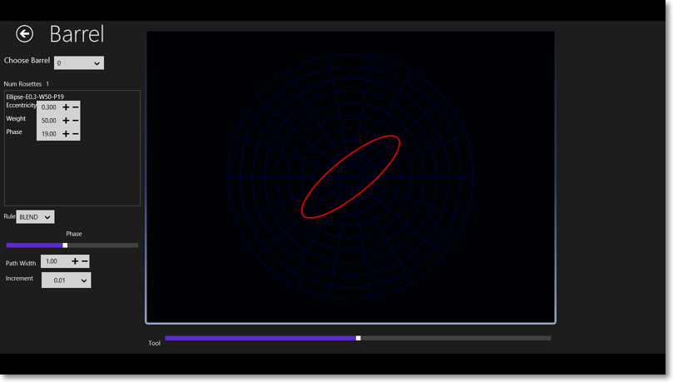
This page is slightly different from the others. Because the rosettes on a rose engine barrel act to offset the headstock from its central position. The values generated by this page are also offsets and not absolute positions.
Therefore the path generated by a tool is dependent on the tools position as well as the arrangement of rosettes on the barrel and finally the overall phase of the barrel.
At the bottom of the display there is a slider to allow you to change the position of the tool relative to the headstock set central position. At the side of the display is another slider to allow you to set the overall phasing of the barrel.
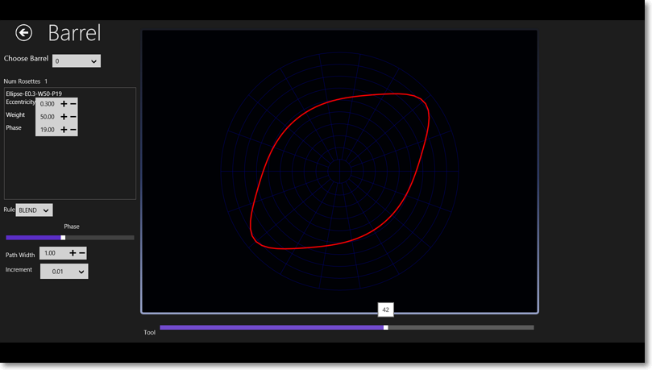
The image above is of the tool path when the tool is offset by a value of 42mm whilst the image below shows the path created by the barrel with a tool offset value of -100mm.

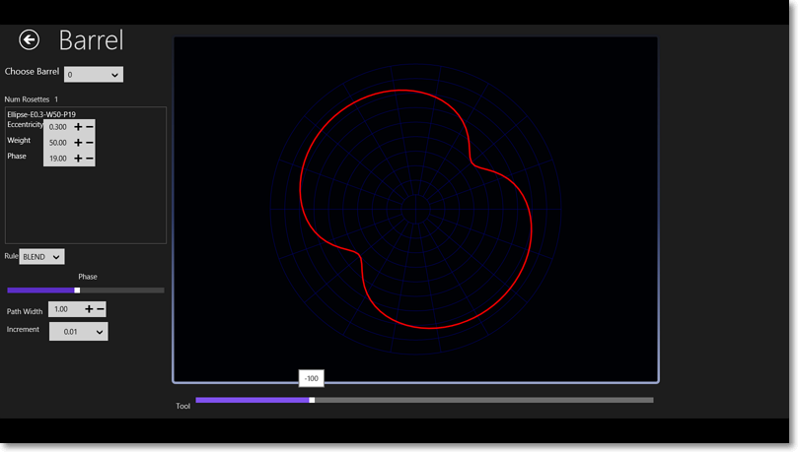

The Barrel
Comprises of one or more rosettes. These rosettes are displayed in the scrollable view to the side of this display. Again like the other pages the rosette parameters can be adjusted and the display is updated to reflect the changed path.
There are buttons on the bottom app bar that allow you to
- Export the path
- Export the barrel data
- Import a barrel
- Create a new empty barrel which is then automatically selected.
- Clear the currently selected barrel this means remove all its rosettes.
- Add a rosette (+)
- Remove a rosette (-)
- Change the grid size
- View the points on the path.

When you choose to add another rosette you the choice options are displayed on a flyout to the right of the screen
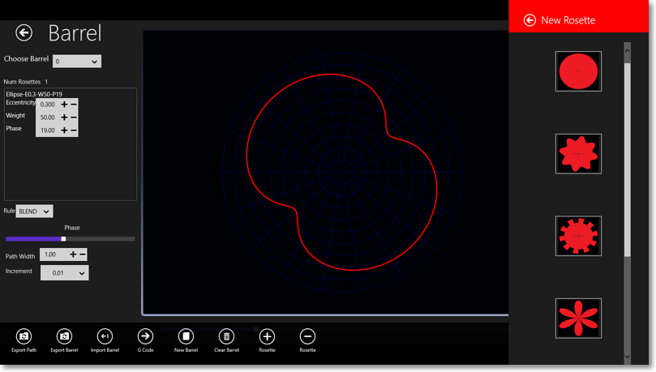

Types of Rosette
You can choose between

An Elliptical - Circular Rosette
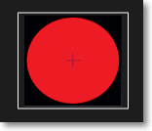
There are 3 parameters
  - Eccentricity - this is the ratio between the two radii. A value of 1 gives a circle a value less than 1 gives an ellipse whose thickness depends on the value. So a value of 0.5 will result in an ellipse whose vertical thickness is half its width
  - Weight - this is a multiplying factor that gives the size of the ellipse. The standard ellipse is 1 unit wide so set the weight to 20 to get one 20 units wide.
  - Phase - this determines the rotation of the ellipse around its centre.

A sine wave rosette
Again three parameters
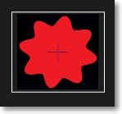
- Frequency – this gives the number of waves
- Weight – this gives the height of a wave
- Phase – the rotation around its centre
Note that if you set the tool offset equal to the weight then the path has lobes and keeps keeps going back to the origin as shown by image below.
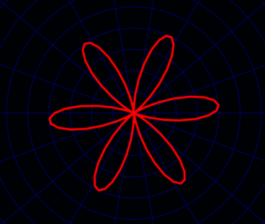
If you make the tool offset less than the weight but still positive you get alternating large and small lobes.
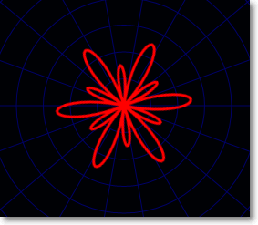

Waves with an offset value greater than the weight look as below. But note you may need to reduce the weight to quite small values to obtain a gentle ripple.
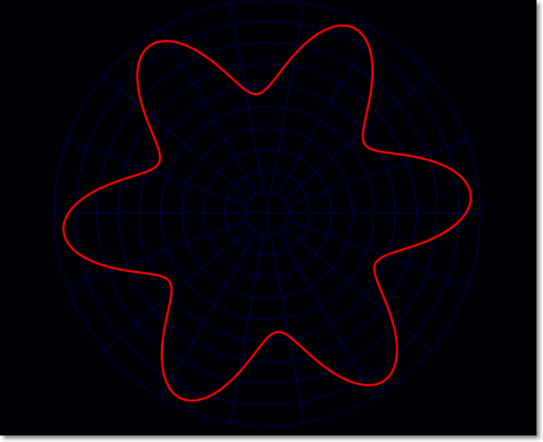

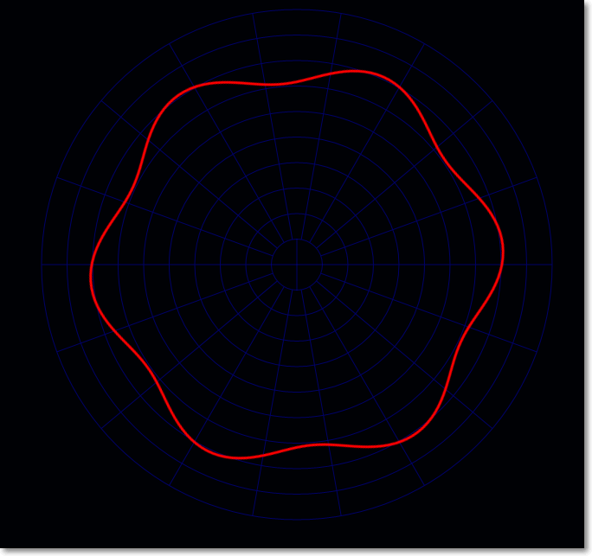
Same tool offset as the previous image with a reduced weight to give a smaller ripple.

Square wave rosette
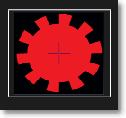
The square wave rosette has the same three parameters as the sine wave and it also behaves in the same way as it is a also a wave (though one with steep sides)
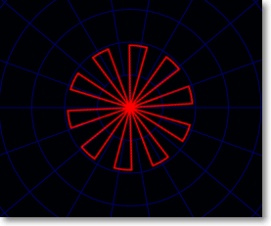
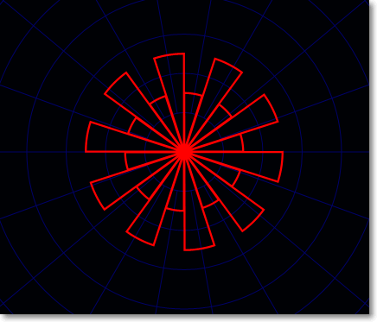
In the above image the tool position is set equal to the rosette weight so path keeps returning to the zero position. The image below shows what happens when the tool offset is less than weight of the rosette.

A petal rosette

Similar to the standard wave it is in fact an absolute wave. That means when on the ordinary wave the values start to go negative on the petal they stay positive. It has the same three parameters
- Frequency – this time there are twice the number of petals as the frequency value
- Weight – same as wave
- Phase – same as wave

Again the tool position determines the shape of the path generated in one rotation. However unlike the wave the bumps are steeper and meet at a cusp.
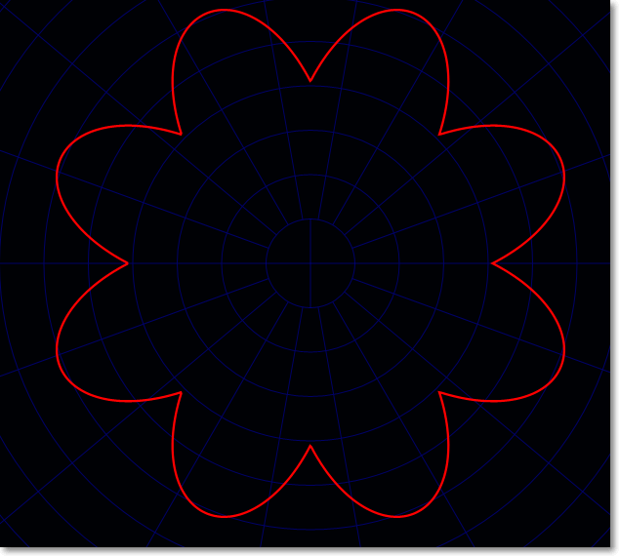
By setting the tool position to negative of the weight you get a petal with sharp this sides
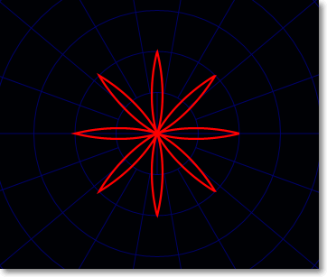

Polygon rosette
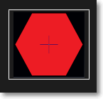
Parameters are
- Number of sides
- Weight
- Phase

Again tool position is important. Setting the tool position to zero gives flat sides
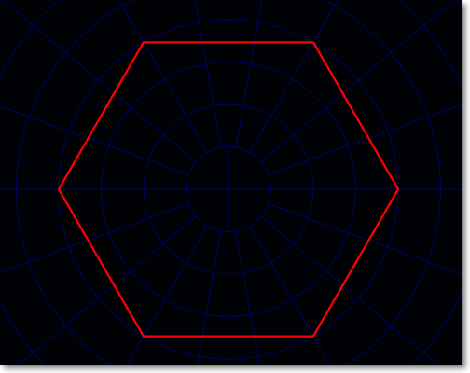
However increasing the tool position tends to make the sides more convex
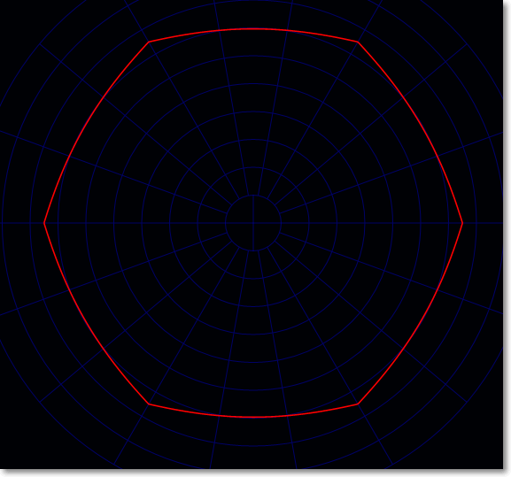
Here the weight is 40 whilst the tool position is set at 35. Alternatively decreasing the tool position makes the sides more concave so long as the tool position is between zero and – the weight.
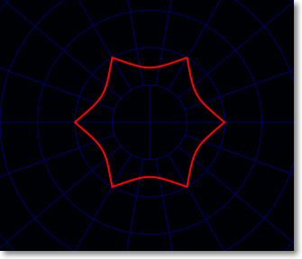
In the image above the weight is 40 and the tool position is -20. You get a different effect when the tool position is less that the negative weight value. The image below is for a weight of 40 and a tool position of -60.
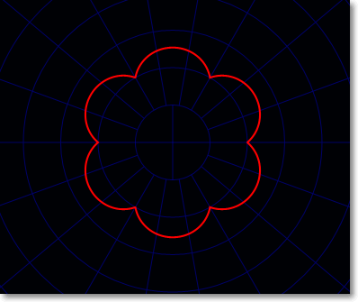

Gear Rosette
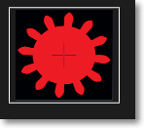
This is still very experimental and the code is not quite correct. It produces the outline of a spur gear. This rosette is totally different from the others because its size is not dependant on tool position. Instead the size of the gear path depends upon a standard set of parameters shown below.
parameters
- The number of teeth in the gear
- The module value
- The pressure angle
- The weight has no effect at present as the diameter of the gear is solely dependent on the previous parameters.
- Phase
- Undercut – currently a fudge factor to get something like the correct tooth shape.

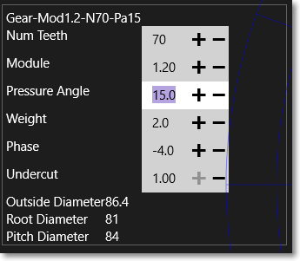

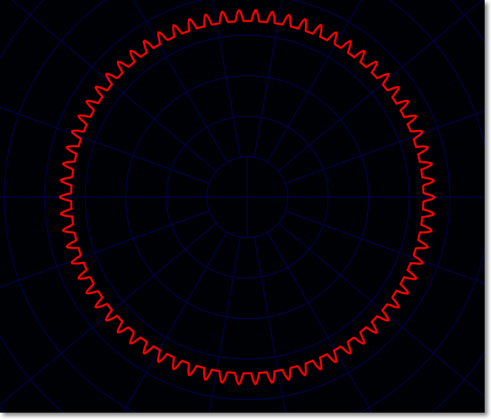
Gear wheel produced with parameters set as in image above. However setting a negative tool position does have an effect and it is to produce an internal gear wheel. That is one with the teeth pointing inward rather than outward. The path below was generated by setting the tool position to -80.
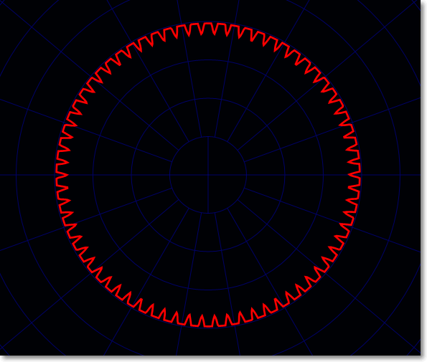
Remember that with all these rosettes a negative tool position simply means that on a real mechanical rose engine the tool is set to the opposite side of the barrel than the rubber.

Multiple Rosettes on a Barrel
When you add several rosettes to a barrel, the path traced is the combined outline of these rosettes.

